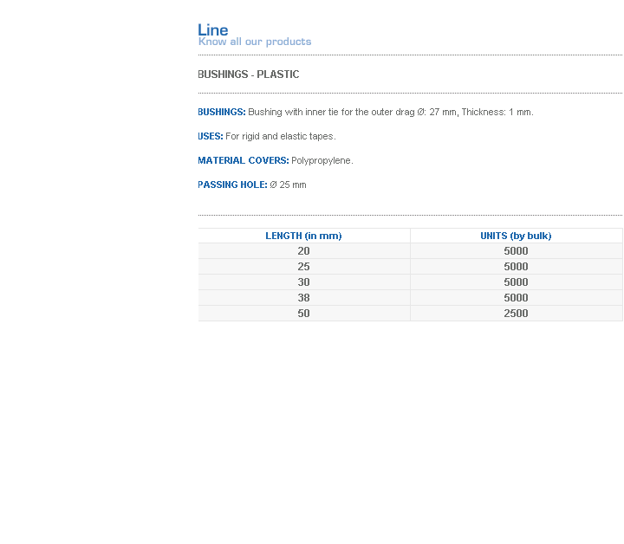
BUSHINGS: Bushing with inner tie for the outer drag Ø: 27 mm, Thickness: 1 mm.
USES: For rigid and elastic tapes.
MATERIAL COVERS: Polypropylene.
PASSING HOLE: Ø 25 mm
Address: Ing.Amoretti Nº 3459 - Ciudadela - Bs. As - Argentina - Postal Code 1702 - Phone: 4654-9043 / 4656-1802 - E-mail: ventas@proux.com.ar

