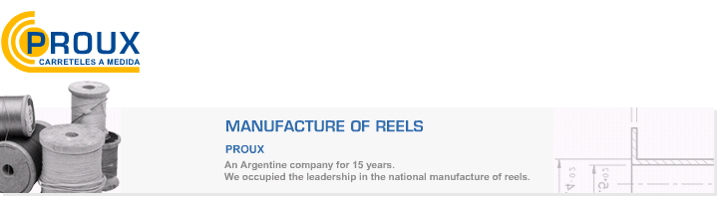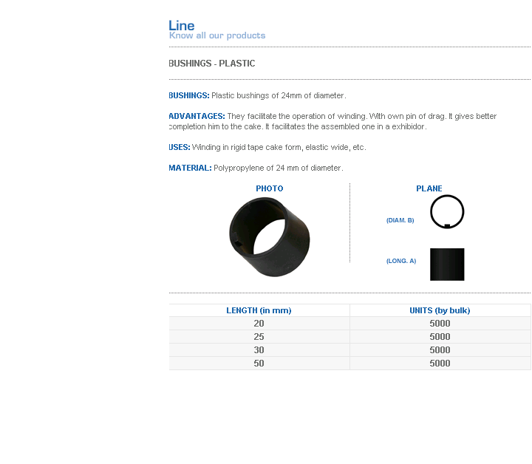
BUSHINGS: Plastic bushings of 24mm of diameter.
ADVANTAGES: They facilitate the operation of winding. With own pin of drag. It gives better completion him to the cake. It facilitates the assembled one in a exhibidor.
USES: Winding in rigid tape cake form, elastic wide, etc.
MATERIAL: Polypropylene of 24 mm of diameter.
Address: Ing.Amoretti Nº 3459 - Ciudadela - Bs. As - Argentina - Postal Code 1702 - Phone: 4654-9043 / 4656-1802 - E-mail: ventas@proux.com.ar

