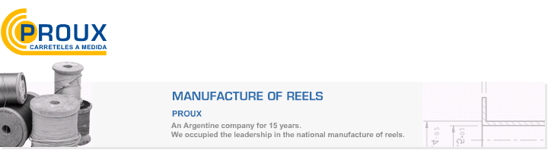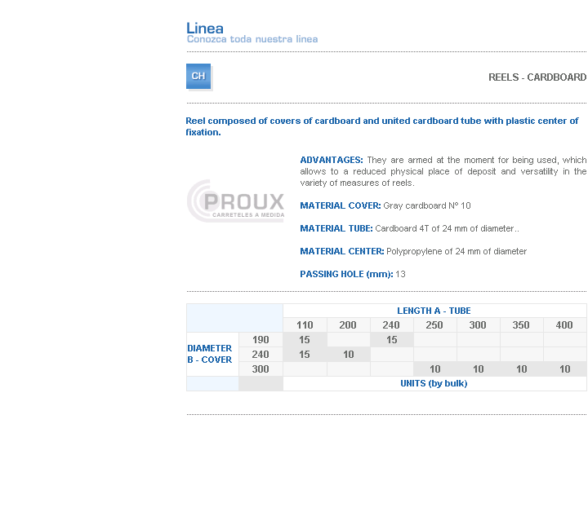
ADVANTAGES: They are armed at the moment for being used, which allows to a reduced physical place of deposit and versatility in the variety of measures of reels.
MATERIAL COVER: Gray cardboard Nº 10
MATERIAL TUBE: Cardboard 4T of 24 mm of diameter..
MATERIAL CENTER: Polypropylene of 24 mm of diameter
PASSING HOLE (mm): 13

Address: Ing.Amoretti Nº 3459 - Ciudadela - Bs. As - Argentina - Postal Code 1702 - Phone: 4654-9043 / 4656-1802 - E-mail: ventas@proux.com.ar

