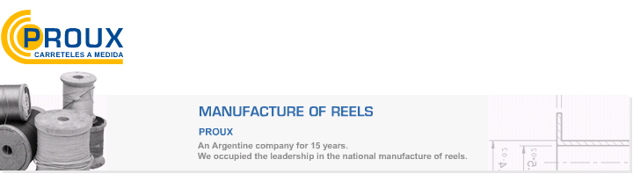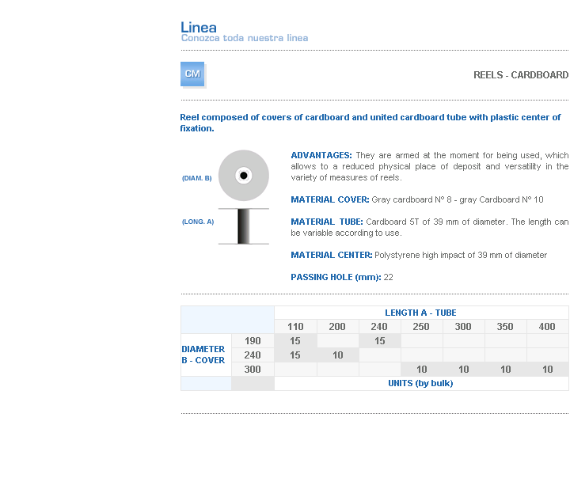
ADVANTAGES: They are armed at the moment for being used, which allows to a reduced physical place of deposit and versatility in the variety of measures of reels.
MATERIAL COVER: Gray cardboard Nº 8 - gray Cardboard Nº 10
MATERIAL TUBE: Cardboard 5T of 39 mm of diameter. The length can be variable according to use.
MATERIAL CENTER: Polystyrene high impact of 39 mm of diameter
PASSING HOLE (mm): 22

Address: Ing.Amoretti Nº 3459 - Ciudadela - Bs. As - Argentina - Postal Code 1702 - Phone: 4654-9043 / 4656-1802 - E-mail: ventas@proux.com.ar

