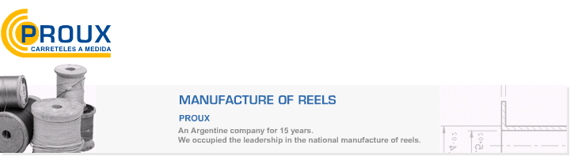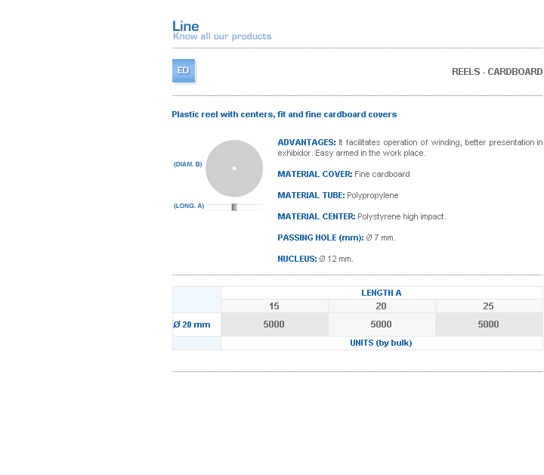
ADVANTAGES: It facilitates operation of winding, better presentation in exhibidor. Easy armed in the work place.
MATERIAL COVER: Fine cardboard
MATERIAL TUBE: Polypropylene
MATERIAL CENTER: Polystyrene high impact.
PASSING HOLE (mm): Ø 7 mm.
NUCLEUS: Ø 12 mm.

Address: Ing.Amoretti Nº 3459 - Ciudadela - Bs. As - Argentina - Postal Code 1702 - Phone: 4654-9043 / 4656-1802 - E-mail: ventas@proux.com.ar

