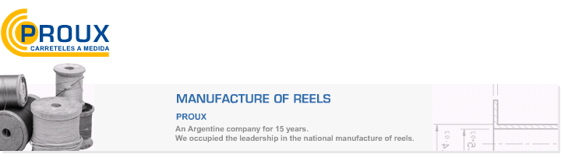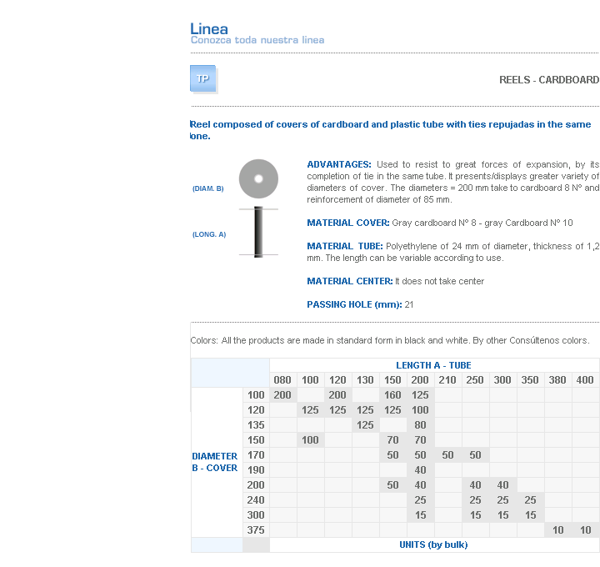
ADVANTAGES: Used to resist to great forces of expansion, by its completion of tie in the same tube. It presents/displays greater variety of diameters of cover. The diameters = 200 mm take to cardboard 8 Nº and reinforcement of diameter of 85 mm.
MATERIAL COVER: Gray cardboard Nº 8 - gray Cardboard Nº 10
MATERIAL TUBE: Polyethylene of 24 mm of diameter, thickness of 1,2 mm. The length can be variable according to use.
MATERIAL CENTER: It does not take center
PASSING HOLE (mm): 21

Dirección: Ing. Amoretti Nº 3459 – Ciudadela – Bs. As – Argentina – CP 1702 – Tel: 4653-4786 / 4488-2895 – E-mail: ventas@proux.com.ar
Address: Ing.Amoretti Nº 3459 - Ciudadela - Bs. As - Argentina - Postal Code 1702 - Phone: 4654-9043 / 4656-1802 - E-mail: ventas@proux.com.ar

