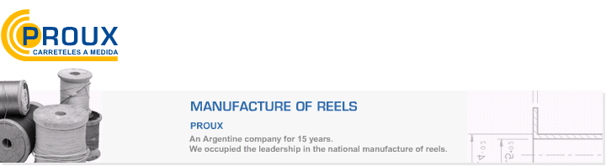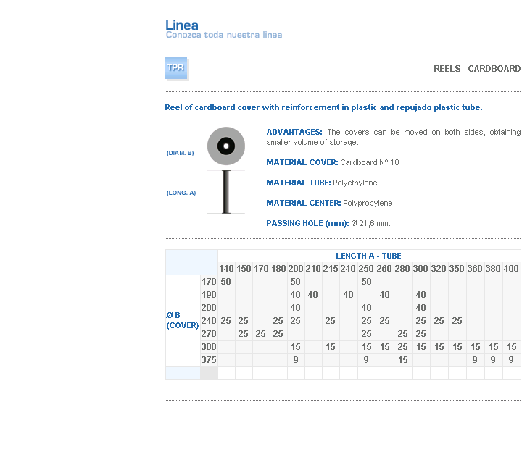
ADVANTAGES: The covers can be moved on both sides, obtaining smaller volume of storage.
MATERIAL COVER: Cardboard Nº 10
MATERIAL TUBE: Polyethylene
MATERIAL CENTER: Polypropylene
PASSING HOLE (mm): Ø 21,6 mm.

Address: Ing.Amoretti Nº 3459 - Ciudadela - Bs. As - Argentina - Postal Code 1702 - Phone: 4654-9043 / 4656-1802 - E-mail: ventas@proux.com.ar

