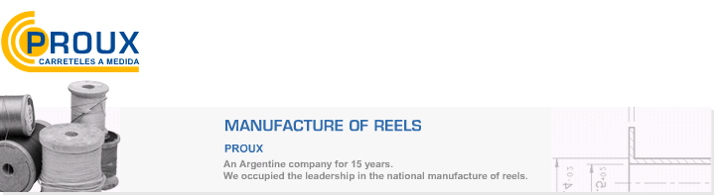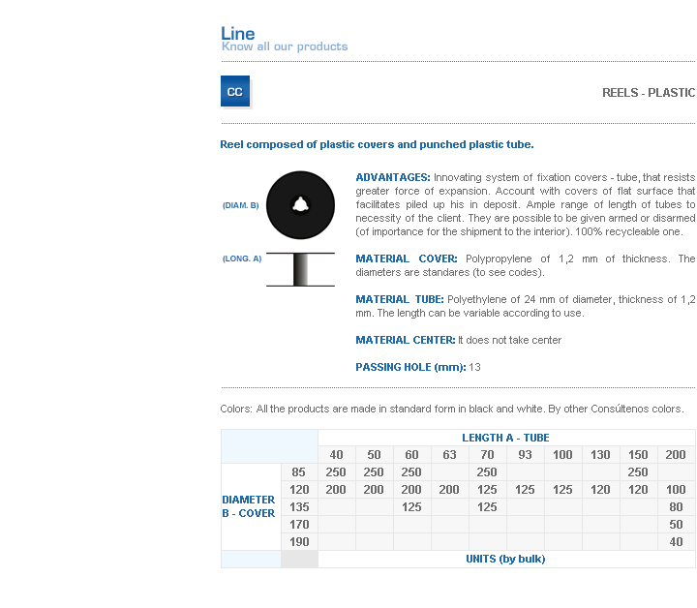
ADVANTAGES: Innovating system of fixation covers - tube, that resists greater force of expansion. Account with covers of flat surface that facilitates piled up his in deposit. Ample range of length of tubes to necessity of the client. They are possible to be given armed or disarmed (of importance for the shipment to the interior). 100% recycleable one.
MATERIAL COVER: Polypropylene of 1,2 mm of thickness. The diameters are standares (to see codes).
MATERIAL TUBE: Polyethylene of 24 mm of diameter, thickness of 1,2 mm. The length can be variable according to use.
MATERIAL CENTER: It does not take center
PASSING HOLE (mm): 13

Address: Ing.Amoretti Nº 3459 - Ciudadela - Bs. As - Argentina - Postal Code 1702 - Phone: 4654-9043 / 4656-1802 - E-mail: ventas@proux.com.ar

