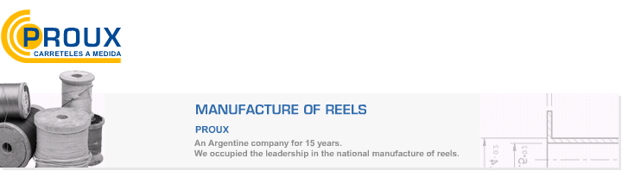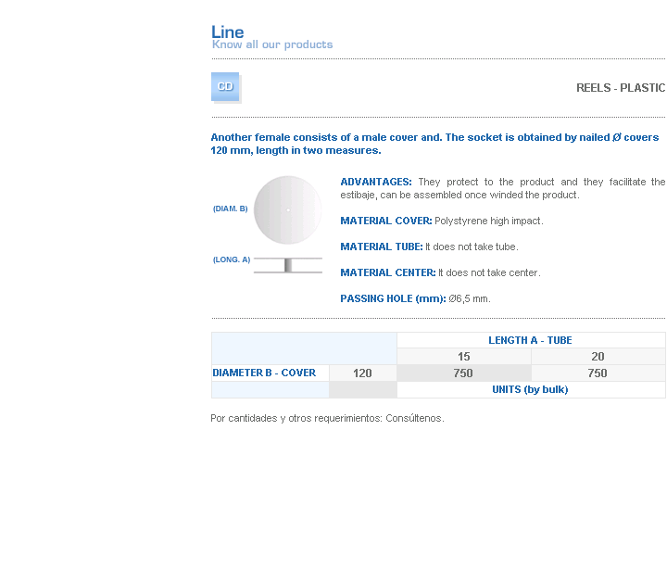
ADVANTAGES: They protect to the product and they facilitate the estibaje, can be assembled once winded the product.
MATERIAL COVER: Polystyrene high impact.
MATERIAL TUBE: It does not take tube.
MATERIAL CENTER: It does not take center.
PASSING HOLE (mm): Ø6,5 mm.

Address: Ing.Amoretti Nº 3459 - Ciudadela - Bs. As - Argentina - Postal Code 1702 - Phone: 4654-9043 / 4656-1802 - E-mail: ventas@proux.com.ar

