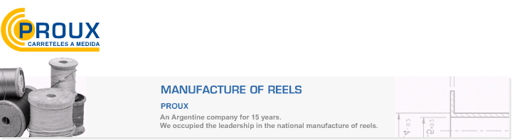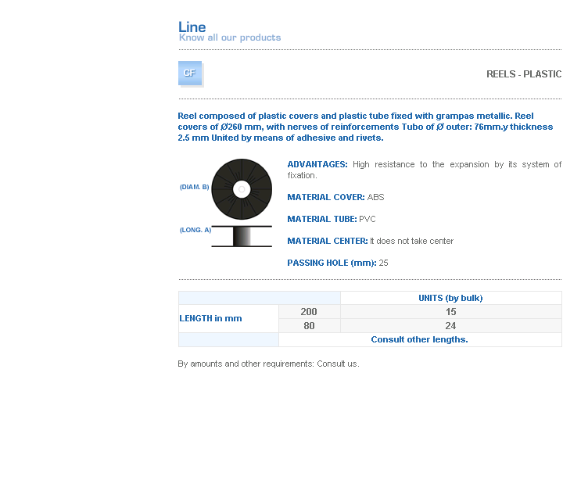
ADVANTAGES: High resistance to the expansion by its system of fixation.
MATERIAL COVER: ABS
MATERIAL TUBE: PVC
MATERIAL CENTER: It does not take center
PASSING HOLE (mm): 25

Address: Ing.Amoretti Nº 3459 - Ciudadela - Bs. As - Argentina - Postal Code 1702 - Phone: 4654-9043 / 4656-1802 - E-mail: ventas@proux.com.ar

