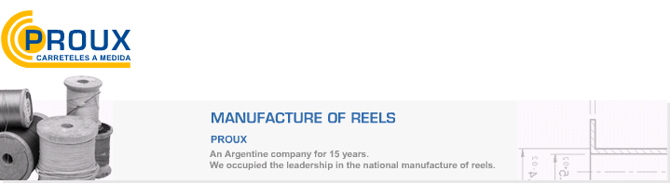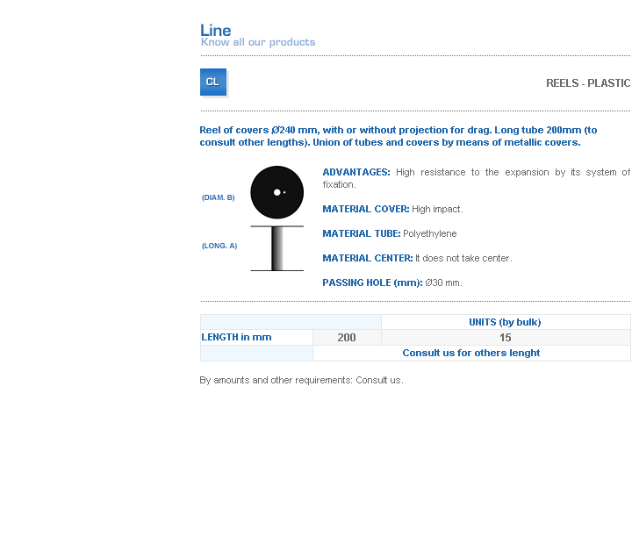
ADVANTAGES: High resistance to the expansion by its system of fixation.
MATERIAL COVER: High impact.
MATERIAL TUBE: Polyethylene
MATERIAL CENTER: It does not take center.
PASSING HOLE (mm): Ø30 mm.

Address: Ing.Amoretti Nº 3459 - Ciudadela - Bs. As - Argentina - Postal Code 1702 - Phone: 4654-9043 / 4656-1802 - E-mail: ventas@proux.com.ar

