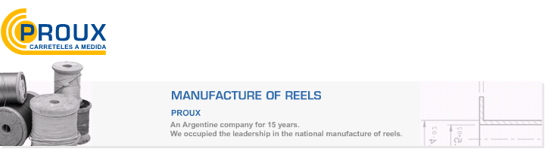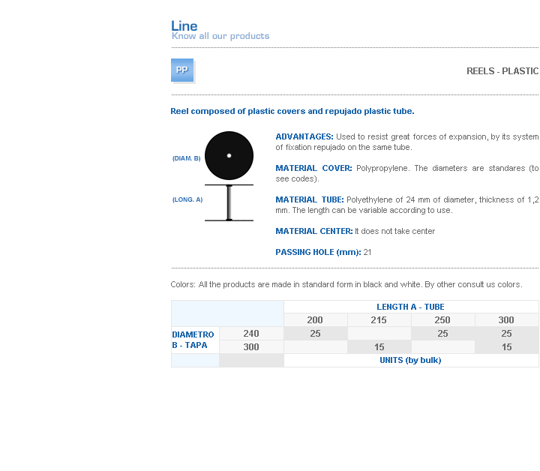
ADVANTAGES: Used to resist great forces of expansion, by its system of fixation repujado on the same tube.
MATERIAL COVER: Polypropylene. The diameters are standares (to see codes).
MATERIAL TUBE: Polyethylene of 24 mm of diameter, thickness of 1,2 mm. The length can be variable according to use.
MATERIAL CENTER: It does not take center
PASSING HOLE (mm): 21

Address: Ing.Amoretti Nº 3459 - Ciudadela - Bs. As - Argentina - Postal Code 1702 - Phone: 4654-9043 / 4656-1802 - E-mail: ventas@proux.com.ar

