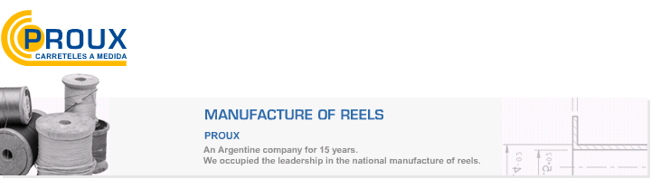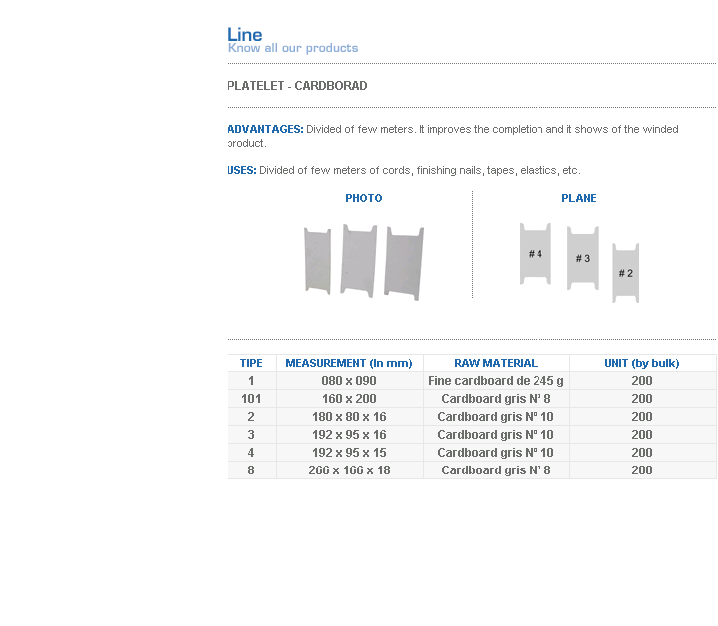
ADVANTAGES: Divided of few meters. It improves the completion and it shows of the winded product.
USES: Divided of few meters of cords, finishing nails, tapes, elastics, etc.

Address: Ing.Amoretti Nº 3459 - Ciudadela - Bs. As - Argentina - Postal Code 1702 - Phone: 4654-9043 / 4656-1802 - E-mail: ventas@proux.com.ar

